EDITORIAL BOARD
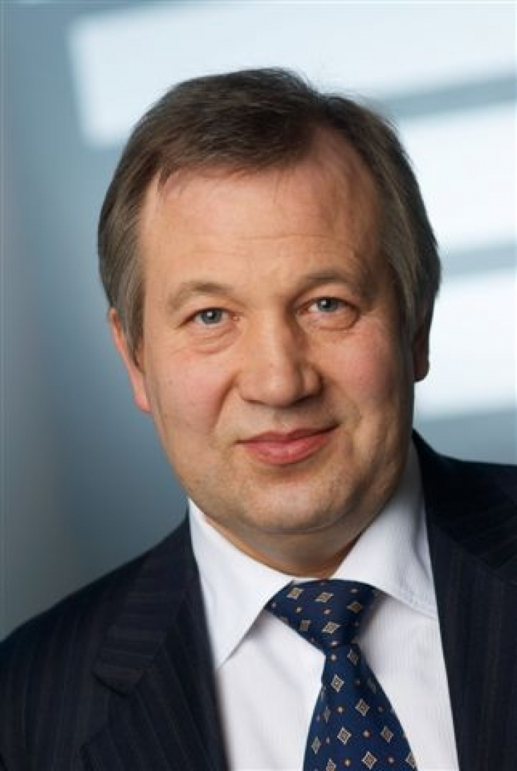  Krasnikov G.Ya. | Dr. Sci. (Tech.), member of the Russian Academy of Sciences (RAS);  ☎ +7 (495) 229-70-00;  ✉ 12/1, 1st Zapadniy proezd, Zelenograd, Moscow, 124460;  @ gkrasnikov@mikron.ru
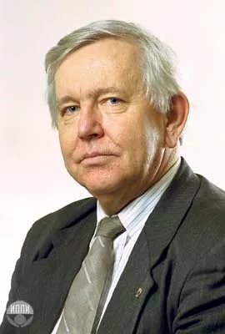  Aristov V.V. | Dr. Sci. (Phys.-Math.), Cor.-Mem. RAS, principal research scientist, IPTM RAS;  @ panchenk@iptm.ru
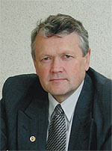  Aseev A.L. | Dr. Sci. (Phys.-Math.), Acad. RAS, vice-president RAS;  ☎ +7(383) 330-05-67;  w.✉ 17, Acad. Lavrentieva, Novosibirsk, 630090;  h.✉ 16, Maltsev's street, Novosibirsk, 630090;  @ aseev@sbras.nsc.ru; al.aseev2011@yandex.ru
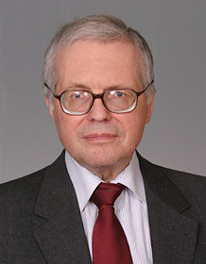  Betelin V.B. | Dr. Sci. (Phys.-Math.), Scientific Supervisor member of the Russian Academy of Sciences (RAS), Professor;  ☎ +7 (495) 719-76-51;  ✉ d. 36, korp.1, Nakhimovsky Prospekt, Moscow, 117218;  @ betelin@niisi.msk.ru
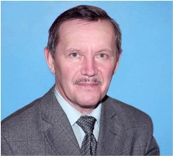  Bokarev V.P. | Ph.D. of Chemical Sciences;  ✉ 12/1, 1st Zapadniy proezd, Zelenograd, Moscow, 124460;  @ vbokarev@mikron.ru
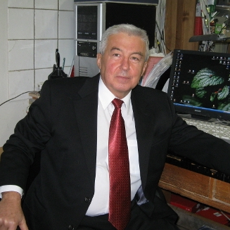  Bugaev A.S. | Dr. Sci. (Phys.-Math.), member of the Russian Academy of Sciences (RAS), Professor;  @ bugaev@cplire.ru
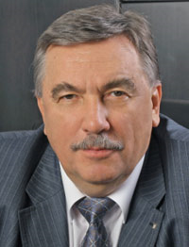  Bikov V.A. | Dr. Sci. (Tech.), Professor;  ☎ +7(499) 735-77-77 (03-05);  mob. ☎ +7 (985)211-35-44;  ✉ d. 6, proezd 4806,;Zelenograd, Moscow, 124460;  @ vbykov@ntmdt.ru
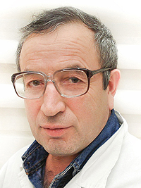  Galiev G.B. | Dr. Sci. (Phys.-Math.), member of the Russian Academy of Sciences (RAS);  ☎ +7 (499) 123-62-22;  ✉p. 5, d. 7, Nagorny p-d, Moscow, 117105;  @ galiev_galib@mail.ru
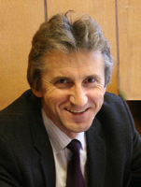  Gorbacevich A.A. | Dr. Sci. (Phys.-Math.), member of the Russian Academy of Sciences (RAS);  @ kfn@miee.ru; aagor137@mail.ru; aag@edu.ioffe.ru; aag@qdn.miee.ru
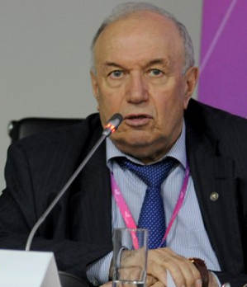  Gornev E.S. | Dr. Sci. (Tech.), principal research scientist, Micron, deputy chief editor;  ✉ 12/1, 1st Zapadniy proezd, Zelenograd, Moscow, 124460;  @ egornev@mikron.ru
Gribov B.G.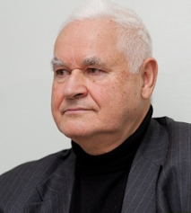 | Dr. Sci. (Chem.), Cor.-Mem. RAS;  @ bor-gribov2009@yandex.ru
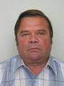  Zajcev N.A. | Dr. Sci. (Tech.), professor, head of Department;  ✉ 12/1, 1st Zapadniy proezd, Zelenograd, Moscow, 124460;  @ nzaytsev@mikron.ru
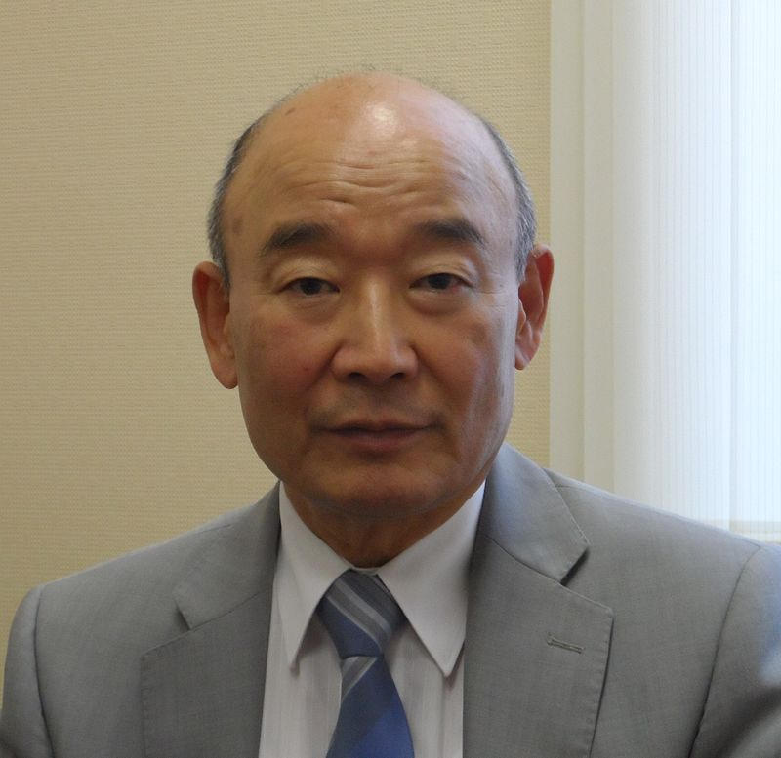  Kim A.K. | Ph.D. of Engineering Sciences;  @ kim@mcst.ru
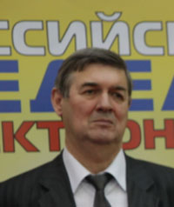  Kritenko M.I. | Ph.D. of Engineering Sciences, Senior Researcher;  ☎ +7 (495) 287-25-00 доб.25-19;  mob. ☎ +7 (963) 693-92-22;  @ m.i.kritenko@rostechn.ru
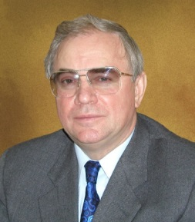  Nemudrov V.G. | Dr. Sci. (Tech.), Professor;  mob. ☎ +7 (985) 923-36-92;  ✉d. 54, proezd Cherepanovykh, Moscow, 125183;  @ nemudrov@mri-progress.ru
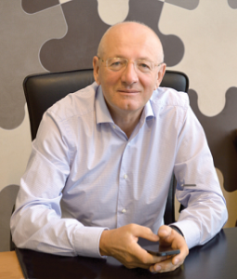  Petrichkovich Ya.Ya. | Dr. Sci. (Tech.), Professor;  ☎ (499) 731-36-91; моб. ☎ +7 (903) 669-22-51;  ✉post office box 19, Zelenograd, Moscow, 124460;  @ slava@elnet.msk.ru
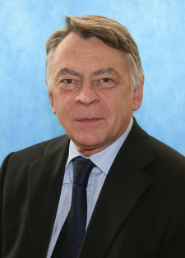  Sigov A.S. | Dr. Sci. (Phys.-Math.), member of the Russian Academy of Sciences (RAS), professor;  @ sigov@mirea.ru
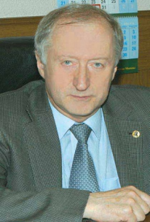  Stempkovskij A.L. | Dr. Sci. (Tech.), member of the Russian Academy of Sciences (RAS), professor;  ☎ 8 (499) 729-98-90;  ✉ 3, Sovetskaya street, Zelenograd, Moscow, 124365;  @ sta109@ippm.ru
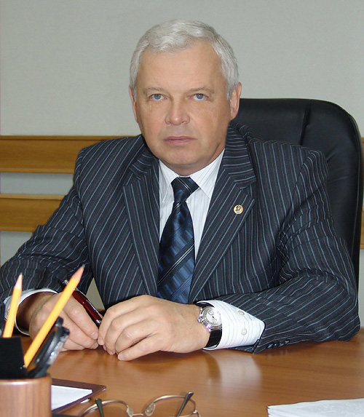  Chapligin Yu.A. | Dr. Sci. (Tech.), Cor.-Mem. RAS, professor;  ☎ +7 (499) 731-27-36;  ✉Bld. 1, Shokin Square, Zelenograd, Moscow, Russia, 124498  @ ar@miee.ru
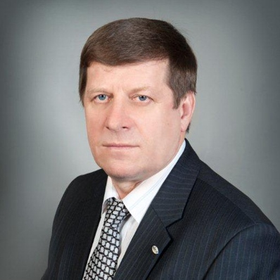  Shelepin N.A. | Dr. Sci. (Tech.), deputy chief editor;  ✉ 12/1, 1st Zapadniy proezd, Zelenograd, Moscow, 124460;  @ nchelepin@mikron.ru
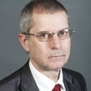  Enns V.I. | Ph.D. of Engineering Sciences;  ✉12/1, 1st Zapadniy proezd, Zelenograd, Moscow, 124460;  @ aenns@mikron.ru

