INFORMATION ABOUT THE EDITOR-IN-CHIEF

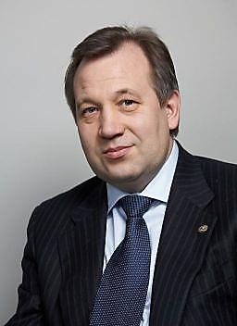
Krasnikov Gennady Yakovlevich - doctor of technical Sciences, academician of the Russian Academy of Sciences, Professor, General Director of "Molecular Electronics Research Institute", Stock Company, the Chairman of the Board of Directors of "Mikron", PJSC, laureate of the State prize of the Russian Federation in the field of science and technology in 2014, well-known specialist in physics of semiconductors, dielectrics and heterostructures, physics of semiconductor devices and fabrication technology products, micro - and nanoelectronics.
Conducted by G. Ya. Krasnikov consistent policy of reducing the backlog of the domestic microelectronics industry of the whole world contributed to its entering position to provide innovative development of all sectors of the economy. Research and development conducted by G.Ya. Krasnikov and his team allowed "Mikron", SC to take a leading position in the country for the development and mass production of integrated circuits for civil and special applications. Under his leadership, established the domestic production of integrated circuits with programmable non-volatile memory, which are now used in Russian documents, transport and banking cards. "Mikron", SC and "MERI", SC the country's only organization developing and manufacturing not only integrated circuits, but also their software.
Special attention academician G. Ya. Krasnikov pays the training of highly qualified scientists and specialists. He heads a Department "Submicron VLSI technology" at national research UNIVERSITY "MIET" and a Department "Micro - and nanoelectronics", national research UNIVERSITY "MIPT". More than 500 employees belonging to Krasnikov G. Ya. engaged in research and development in the group of companies "Mikron", many of them undergo continuous training in foreign enterprises and technology partners with a leading position in the world in the field of submicron and nanotechnology.

