INFORMATION ABOUT THE JOURNAL

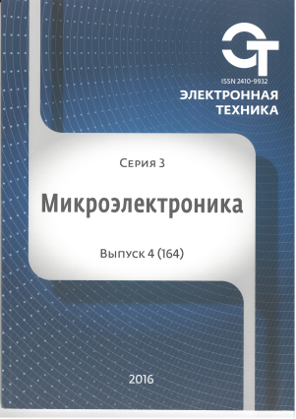
The journal "Microelectronics" was founded in 1965. The Publishing resumed in 2014 under the name "Electronic engineering. Series 3. Microelectronics". It is dedicated to the technological, physical and circuit aspects of micro - and nanoelectronics. Special attention is paid to new trends in lithography (optical, x-ray, electron, ion), etching, doping, deposition and planarization for submicron and nanometer levels. A significant place is given to plasma technologies, molecular beam epitaxy and dry etching, the methods of investigation and control of surfaces and multilayer structures. Discusses the instrument-technological modeling and diagnostics of technological processes in real time. Articles on semiconductor devices based on new physical phenomena such as quantum size effects and superconductivity. This research covers heterostructures, nanotransistors, and solid state devices, quantum bits (qubits). Discusses the problems of analysis and synthesis of electronic circuits in bipolar and field-effect transistors, particularly CMOS - and BiCMOS-circuits. The journal is intended for specialists of research institutes, universities and industrial laboratories, and for graduate students.
The basic thematic sections of the journal:

• Physical phenomena, calculation and design of semiconductor devices;
• Development and manufacturing technology of semiconductor devices;
• Assembly technology;
• Special technological and measuring equipment for manufacturing semiconductor devices;
• Properties of materials used in the manufacture of semiconductor devices and their interaction with the parameters of the devices, the size factor and technological standards;
• Parameters and measurement methods;
• Quality control and reliability;
• Mathematical modeling applied to micro-and nanoelectronics;
• Application, Economics and organization of production of semiconductor devices.

The main headings are:

1. Physical phenomena
2. Development and design
3. Economics and organization of production
4. Processes and technology
5. Properties of materials
6. Technological and measuring equipment
7. Mathematical modeling
8. Reliability
9. Student works
The journal is published in paper version in Russian with titles and abstracts in English and also has an electronic version of the table of contents of all published in 2014 journals and abstracts published in these papers, presented in free access on the journal website http://www.niime.ru/zhurnal-mikroelektronika and the national electronic library http://elibrary.ru/defaultx.asp
Periodicity: quarterly.
Volume: 90-110 pages.
Format: A4 circulation: 500 copies
ISSN 2410-9932
International name: «ELECTRONIC ENGINEERING. Series 3. MICROELECTRONICS»
EAN-13: 9772076424028
Founder: «Molecular Electronics Research Institute», Stock Company
Founder address: 124460 Moscow, Zelenograd, 1st Zapadniy proezd, 12/1 Tel. 8 (831) 439-09-43
E-mail: globalsales@mikron.ru
The edition is registered by Federal service on supervision in sphere of mass communications (the certificate on the state registration of August 14, 2013 PI № FS77-55092).
Subscription index: 80408 in the catalog OAO "Rospechat" Agency
The journal is included in the list of periodicals recommended by higher attestation Commission for publication of basic results of candidate and doctoral theses.
The journal is included in bibliographic and abstract database of Russian science citation index.
All submitted articles are reviewed. Reviewers are the members of the editorial Board and engaged experts in the fields of science and industry related micro - and nanoelectronics.
At this point in the journal has published more than 113 articles, the vast majority of which are high-qualified Russian and foreign scientists and experts. The publication quoted by such leading universities, such as Moscow state University. M. V. Lomonosov, national research nuclear University MEPhI, Institute for design problems in microelectronics RAS, Moscow State Technical University. N. Uh. Bauman (national research University), and many others. In the future, the journal plans to increase the number of regional authors, expanding direct contacts with regional universities and research institutions.
Editorial address: 124460 Moscow, Zelenograd, 1st Zapadniy proezd, 12/1; tel: +7 (495) 229-70-43;
e-mail: journal_EEM-3@mikron.ru; website: http://www.niime.ru/zhurnal-mikroelektronika/

