SUBSCRIPTION

In this section you will find information about how to subscribe to the journals "Electronic engineering. Series 3. Microelectronics", and also about possible access to electronic versions of journals.
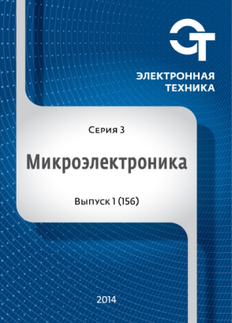
The journal is designed for a wide range of professionals, who develop and manufacture products for micro - and nanoelectronics. The journal comprehensively covers the modern achievements and problems of micro - and nanoelectronics in all spheres of scientific and production activities from technology to Economics. The journal is open for both domestic and foreign authors.

For the convenience of readers and subscribers, we tried to consider all the possible ways of subscription, among which you can choose the most convenient. We offer you:

- To subscribe to printed versions of journals through THE MAIL OF RUSSIA AND ALTERNATIVE AGENCY (Subscription index 80408 in the catalog of JSC Agency "Rospechat'");

- Subscribe to a journal or purchase individual editions of journals and articles in electronic form (through the purchase of rights to use the electronic version of the journal or article on the website http://elibrary.ru/defaultx.asp);

- To subscribe directly to the editorial:
• for legal persons letter of guarantee signed by the head and chief accountant with the details of the enterprise (a scan of the letter can be sent to the email address: nvoronova@niime.ru and the original by mail: 124460 Moscow, Zelenograd, 1 Zapadniy proezd, 12, building 1),
• for individuals on request directed to the email address of the editorial office: nvoronova@niime.ru.

The journal is published 4 times a year since 1965,
Publishing has been resumed in 2014
The license of Roskomnadzor: PI №FS77-55092 from 14.08.2013
Founder: "Molecular Electronics Research Institute", Stock Company

Editor-in-Chief: doctor of technical Sciences,
Academician of the Russian Academy of Sciences, G. Ya. Krasnikov

Справки по тел.: (495) 229-70-43, e-mail: journal_EEM-3@mikron.ru

On the website http://www.niime.ru/zhurnal-mikroelektronika and the national electronic library http://elibrary.ru/defaultx.asp free access to the table of contents are all released in 2014 journals and abstracts published in these works.

Full-text versions of articles will be available on the website http://www.niime.ru/zhurnal-mikroelektronika and in the electronic library http://elibrary.ru/defaultx.asp 2 years after publication in the journal.

On all questions of purchase and subscription to our journal please contact the editorial office:
- ☎ +7 (495) 229-70-43,
- ✉ nvoronova@niime.ru

